**Project Report Template**

**RECRUITING ASSISTANT FOR HR MANAGERS**

**1 INTRODUCTION :-**

**Overview**

Sourcing candidates: The recruiting assistant is responsible for identifying potential candidates through various channels such as job boards, social media, and employee referrals.

**Purpose**

The project helps with various HR-related tasks such as recruiting, hiring, onboarding, employee relations, and benefits administration.

**2 Problem Definition & Design Thinking**

**Ideation & Brainstorming Map**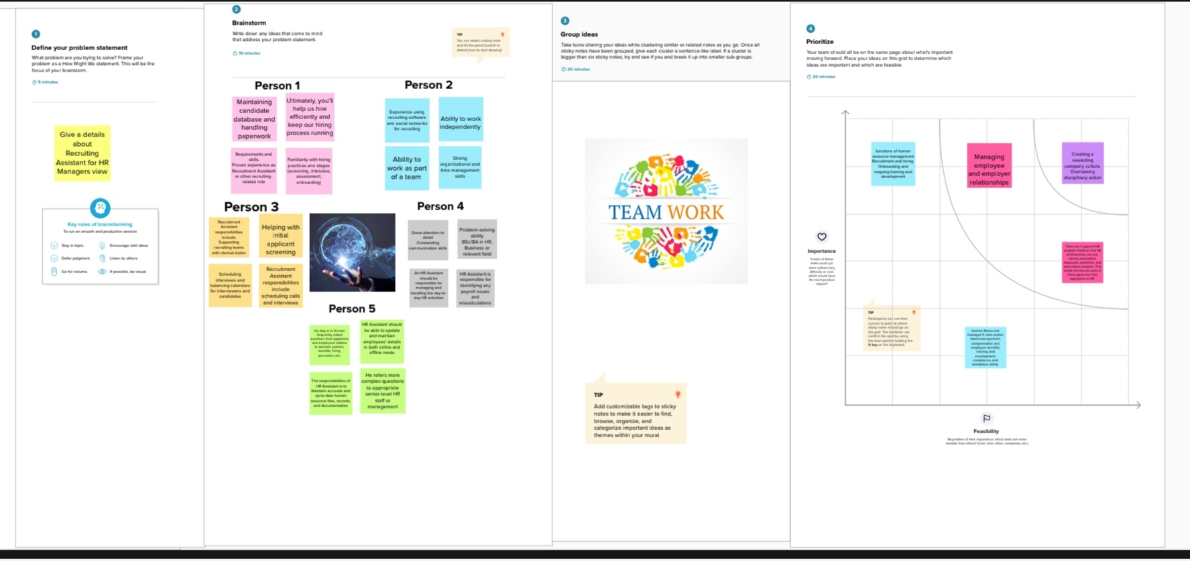

**Empathy Map**

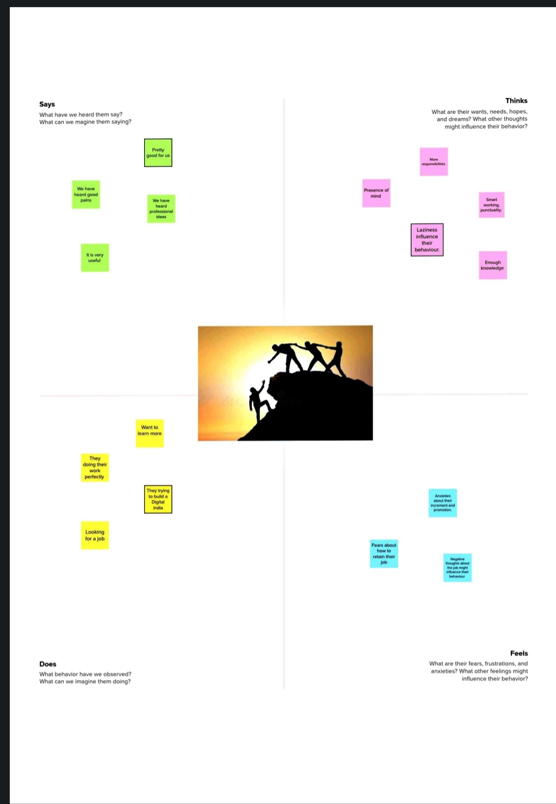

|  |  |
| --- | --- |
| **Object**  **Name** | **Fields in the object** |
| 1. **Object**   Job Posting  site | |  |  | | --- | --- | | FIELD LABEL | DATA TYPE | | Job posting site URL | URL | | Status | Pick list | | Technical site | Pick list | | Description | Pick list | |
| 1. **Object**   Review | |  |  | | --- | --- | | FIELD LABEL | DATA TYPE | | REVIEW | AUTO NUMBER | |

**3. RESULT :-**

**3.1 Data Model**

**3.2 ACTIVITY AND SCREENSHOT**

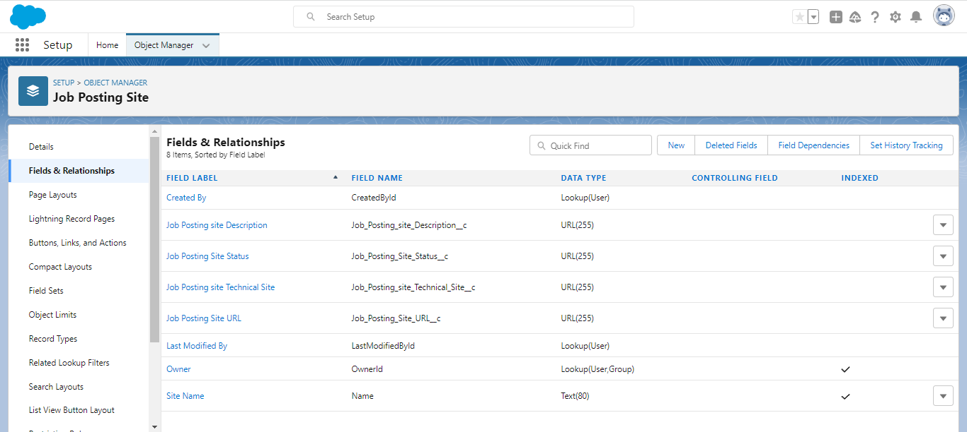

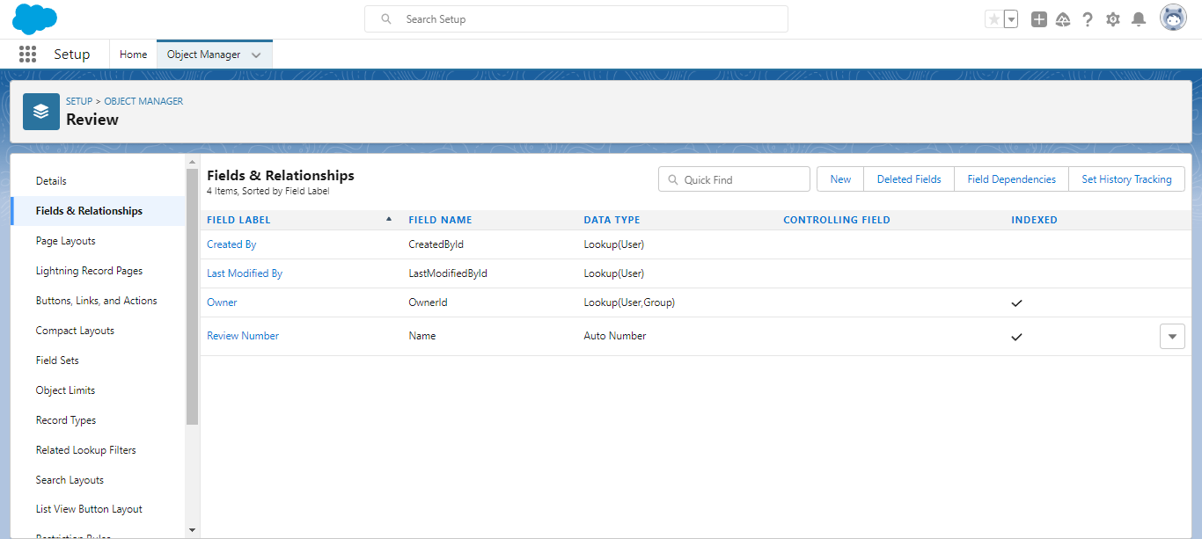

**4 Trailhead Profile Public URL**

**Team Lead** - https://trailblazer.me/id/prasg39

**Team Member 1** - https://trailblazer.me/id/pdharshini210

**Team Member** 2 - https://trailblazer.me/id/dmariyappan

**Team Member 3** - https://trailblazer.me/id/ssurya253

**Team Member 4** - https://trailblazer.me/id/anayan9

**Project Report Template**

**5. ADVANTAGES : -**

* Can help ensure a positive candidate experience, which is essential for building a strong employer brand.
* Can help expand the reach of job postings by posting on various job boards and social media platforms.
* Can manage candidate data efficiently, making it easier for the HR manager to review applications and make informed hiring decisions.
* Can be a cost-effective solution compared to hiring additional HR staff or outsourcing recruitment to a third-party provider.
* Can handle administrative tasks, such as scheduling interviews and responding to candidate inquiries, freeing up time for the HR manager to focus on other tasks.

**DISADVANTAGES :-**

* Lack of Expertise: Recruiting assistants may not have the same level of expertise as an HR manager, which can lead to mistakes in the recruitment process.
* Communication Issues: Miscommunication between the recruiting assistant and HR manager can cause misunderstandings that can impact the recruitment process
* Limited Availability: The recruiting assistant's workload and schedule may limit their availability for candidate inquiries and other recruitment-related tasks.
* Dependency: Over-reliance on the recruiting assistant can result in a lack of engagement and involvement in the recruitment process
* Cost: Hiring a recruiting assistant can be costly, especially for small businesses with limited budgets.

**6. APPLICATIONS :-**

* Review the applicant's skills and assess whether they align with the requirements of the position. Look for evidence of specific skills such as communication, problem-solving, and teamwork.
* Consider whether the applicant's values, work style, and personality align with the company culture. Look for evidence of teamwork, collaboration, and adaptability.
* Look for relevant education, work experience, and any certifications that may be necessary for the role
* Grammar and spelling: Pay attention to the applicant's grammar and spelling, as errors can be an indication of poor attention to detail.

**7. CONCLUSION :-**

* The recruiting assistant may also play a role in promoting the employer brand and helping to attract top talent to the organization. This could include developing job descriptions and recruitment materials, attending job fairs and other recruiting events, and maintaining a strong online presence on social media and job search platforms.
* Overall, the role of a recruiting assistant for an HR manager is a vital one, helping to ensure that the organization has the right people in the right positions to achieve its goals. It requires a strong work ethic, excellent communication and organizational skills, and a commitment to supporting the success of the organization and its employees.

**8. FUTURESCOPE :-**

* I can assist in creating a clear and detailed job description for the HR manager role, including the responsibilities, qualifications, and necessary skills.
* Once you have received resumes, I can assist in screening them to identify the most qualified candidates based on the job requirements and qualifications.
* I can help schedule and conduct initial interviews with the shortlisted candidates via phone, video, or chat to assess their suitability for the role.
* I can assist in conducting salary benchmarking research to ensure that the company offers competitive salaries for the HR manager position.
* I can help you conduct exit interviews with departing employees to gain insights into the reasons for their departure and identify areas for improvement within the organization.